**Termwork 5**

NAME: XXX DATE: 25/05/2023

USN: 2GI20CSXXX

Button 1 pressed Button 2 pressed

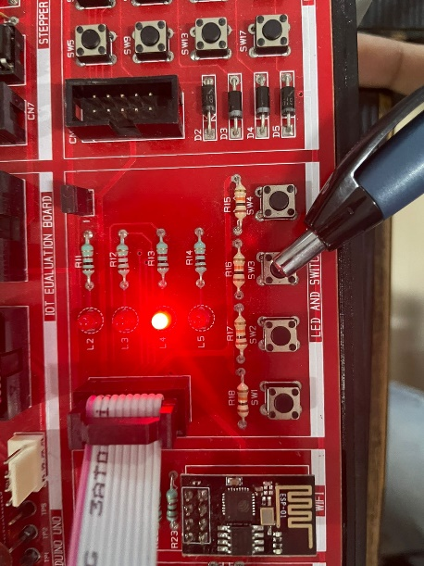 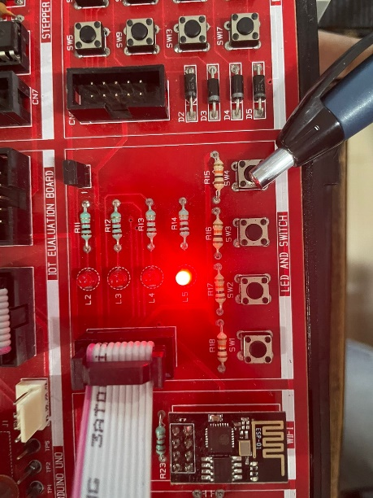

Button1 and Button 2 pressed Serial monitor

